## 7.2 Computing Innovations Found In Every Field

Computing innovations can be found in nearly every field of study. Some commonplace examples are the effects that machine learning and data mining have had on fields such as medicine, business, and science.

## Machine Learning, Data Mining

When it comes to innovations based on computing, machine learning, data mining, and creative commons have had some of the most influential effects on the fields that they have been applied to.  
 Machine learning, the study of algorithms and statistical models that computer systems use to perform a specific task without explicit instructions is possible by relying on patterns and inferences made by the repeated trials of a task. It is also commonly referred to as artificial intelligence. For details on how machine learning works, refer to the machine learning resources below.

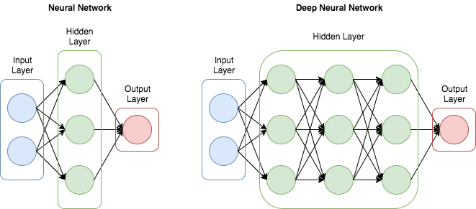

Data mining is the process of discovering patterns in large data sets by utilizing techniques such as machine learning, statistics, and database systems. In this digital age, we produce astronomical amounts of data, much of which is saved by various systems all over the world. Instagram, for example, holds the daily happenings of hundreds of thousands of individuals. To the average person, this information would, at most, serve as entertainment, however, if you have this sort of information about a neighborhood, or a town, or a city, you could know what sorts of businesses will flourish or fail based off of observed behaviors. The heart of data mining is finding hidden patterns in seemingly random data.

## Planning for Future Development

With these powerful innovation tools, companies must utilize their computing power, which includes planning for future developments. To do this, we use something called Moore’s Law, which states that the number of transistors on a microchip doubles every two years and the cost of computers is halved. It also states that the growth of the microprocessors is exponential.

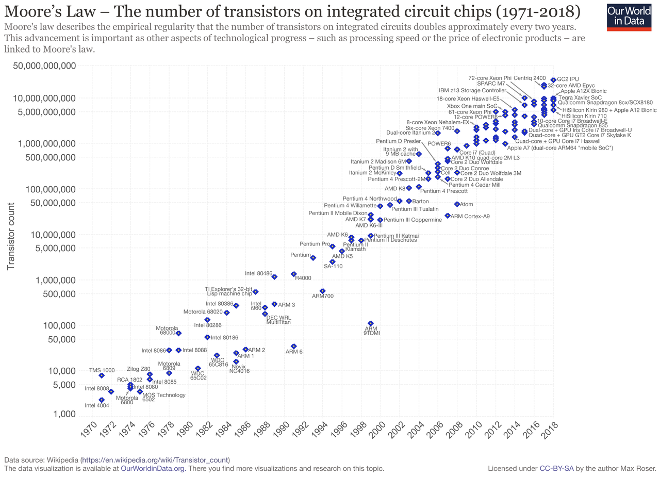

Despite the name, Moore’s Law is not a law. It was a prediction that came true for many years, however, as it is exponential, it must come to an end. We have been diverging from Moore’s law for several years now as we move towards ever more powerful methods of computation.

## Resources

* Machine Learning
  + Basic
    - <https://www.youtube.com/watch?v=R9OHn5ZF4Uo>
  + Advanced
    - <https://www.youtube.com/watch?v=aircAruvnKk&feature=youtu.be>
* Machine Learning Experiments
  + <https://experiments.withgoogle.com/collection/ai>
* Moore’s Law and its Death
  + <https://www.youtube.com/watch?v=2ugsWUv-DVs>
  + <https://www.youtube.com/watch?v=WzaZFyn-iJ0>

## Vocabulary

* Machine Learning: The study of algorithms and statistical models that computer systems use to perform a specific task without explicit instructions. Also called Artificial Intelligence.
* Moore’s Law: A prediction that the number of transistors on a microchip doubles every two years and the cost of computers is halved. It also states that the growth of the microprocessors is exponential.
* Transistor: A semiconductor device used to amplify or switch electronic signals and electrical power composed of semiconductor material usually with at least three terminals for connection to an external circuit.
* Microprocessor: A computer processor that incorporates the functions of a central processing unit on a single integrated circuit or sometimes up to 8 integrated circuits.